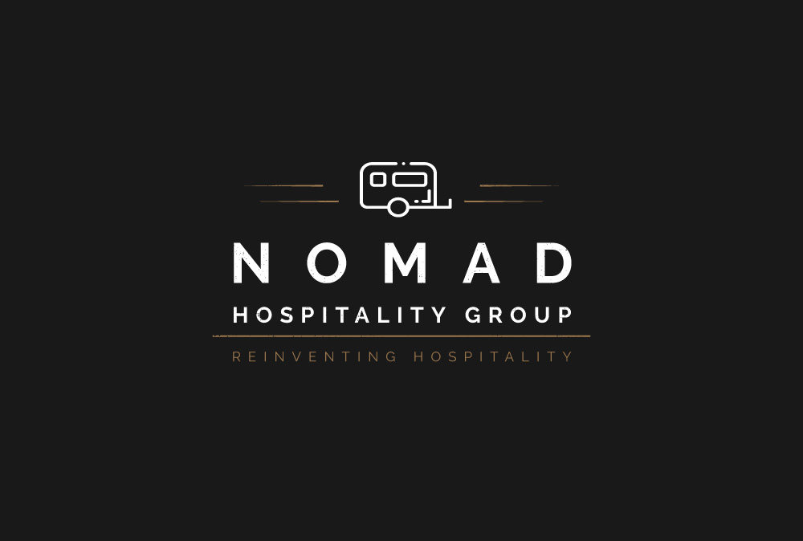

https://www.nomadhospitality.com

New Team Member Welcome Orientation Letter

Cheers!! Welcome aboard the Nomad Group Team!,

We are delighted you have accepted the offer to join Nomad and the Koptel Hotel team as the latest member of our Operations Team. We believe that you will make a substantial contribution to Nomad’s values of non-discrimination, teamwork, being Pro-Active, and the NoMAD CAN DO spirit and work culture.

Kindly visit https://www.nomadhospitality.com for background company information and corporate mission statement. This will help lays a solid foundation for your new career with us. Orientations occupies a short but influential time for you to successfully assimilate into Nomad Hospitality Group’s work culture and helps you align your career goals with that of Nomad Hospitality Group’s corporate vision.

Let Nomad Hospitality Group be your launchpad towards achieving not only personal success, but also, together as a valued team member, be inspired to greater heights!

Orientation week’s agenda:

- Day 1 : Welcome – Property tour, Overview
- Day 2 : Nomad Way – Why and how of implementation
- Day 3 : On Boarding – Steps through checklist and priorities
- Day 4 : Bespoke Framework – Introduction to Nomad’s bespoke verticals
- Day 5 : Documentation – Discuss with team members and duty actions log
- Day 6 : Compliance – SOPs, Your ideas, MQS, ROTi, feedbacks
- Day 7 : Final Day – Recap and reconciliation, Q&A, Github setup etc

To help you gain a better understanding of Github, Nomad’s implementation, we will help you setup and integrate your Github account. The date, time and location of this event will be provided to you on your first day of work. You may also visit the Nomad Human Resource website at https://www.hr.nomad.com if you are interested in reviewing in advance of this event the wide array of benefits that may be available to you during your employment with Nomad.

For the first few months in your new position, you will be assigned an orientation buddy who will help you get acclimated to your new position, Koptel Hotel and Nomad Hospitality Group. Your team buddy and you will also meet throughout your orientation period to ensure you are settling in to your new role and to discuss job expectations and goals.

Again, welcome to our team! If you have questions or need additional information, please do not hesitate to contact your orientation buddy. Nomad Hospitality Group welcomes YOU to the team.

Sincerely,

[Supervisor Name]

[Supervisor Title]

*Adapted from and used with permission from Jean Barbazette, Successful New Employee Orientation published by Pfeiffer & Associates, copyright Jean Barbazette, 1994 www.thetrainingclinic.com.

